Advanced Software Engineering

Take home exam

Public Square App

Description of Public Square App:

I have created a web application in responsive to mobile app by using responsive CSS , so that look and feel of a web app is same as mobile app.

Design:

1. Architectural diagram for Gift Finder App:

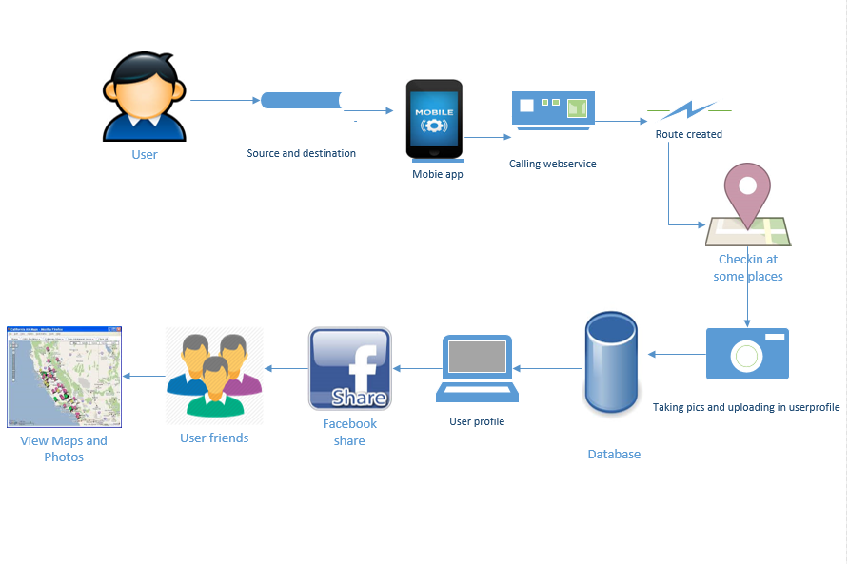

1. Class diagram for Public Square App:

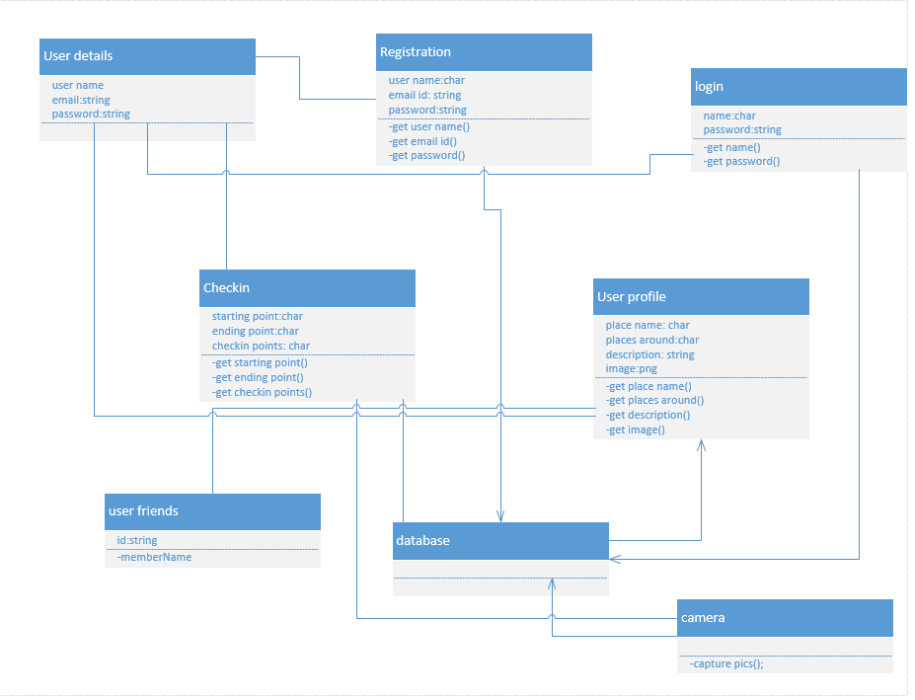

b. Mobile User Interface:

i. Own Design:

Screenshots:

The Home page I have created using HTML file,CSS .

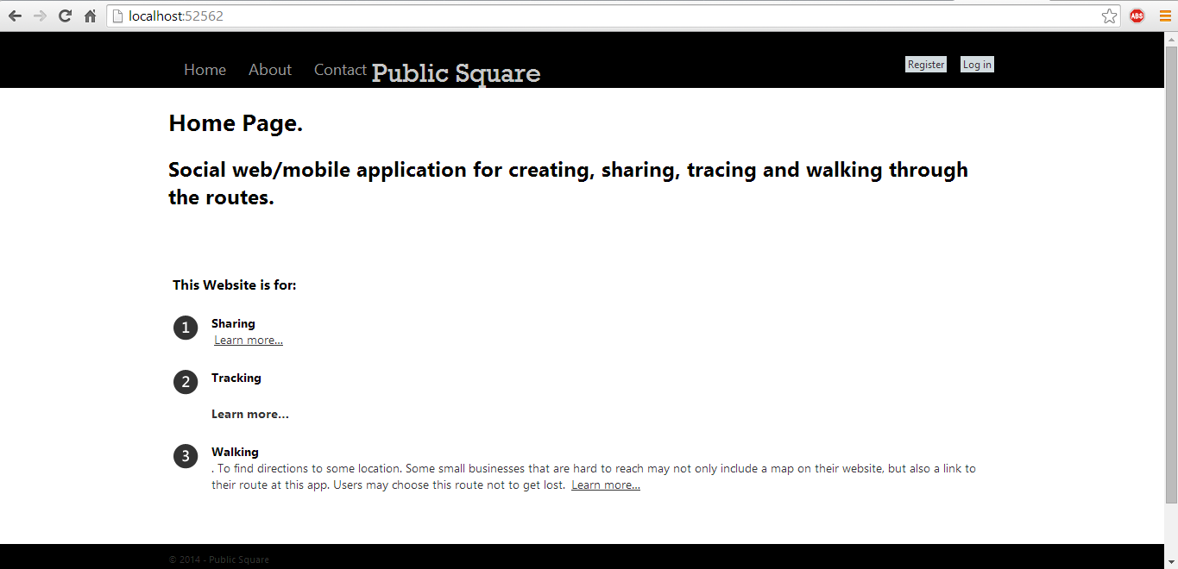

If user is new he needs to know about the site first.

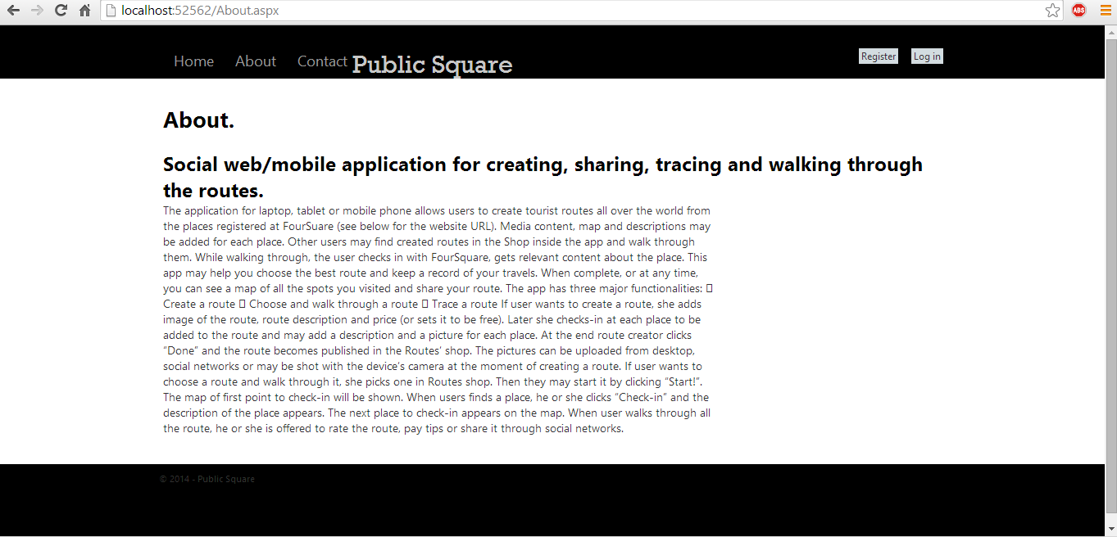

If user has any doubt you can contact the site manager.

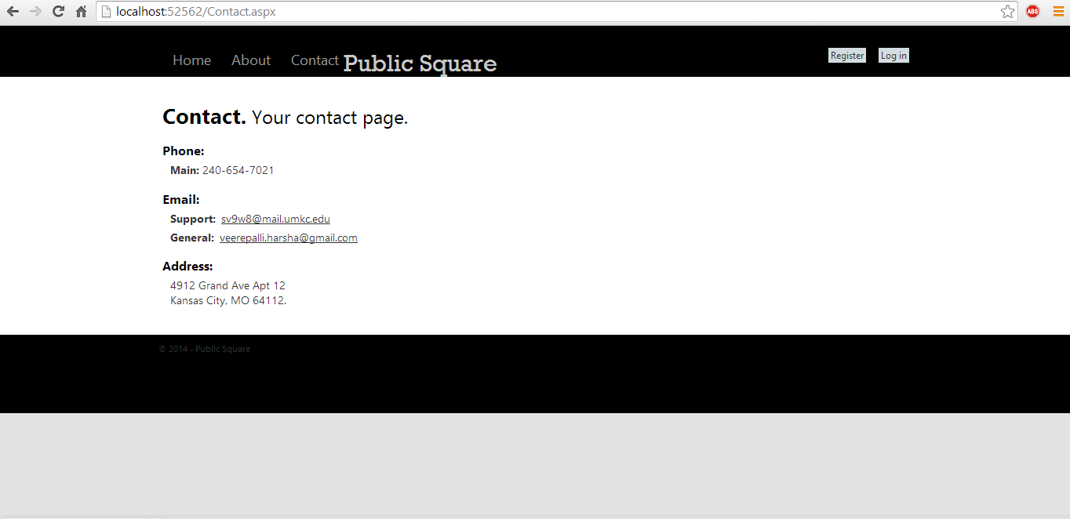

If user wants to use these app first he/she needs to download and create a account(Sign Up) in it.

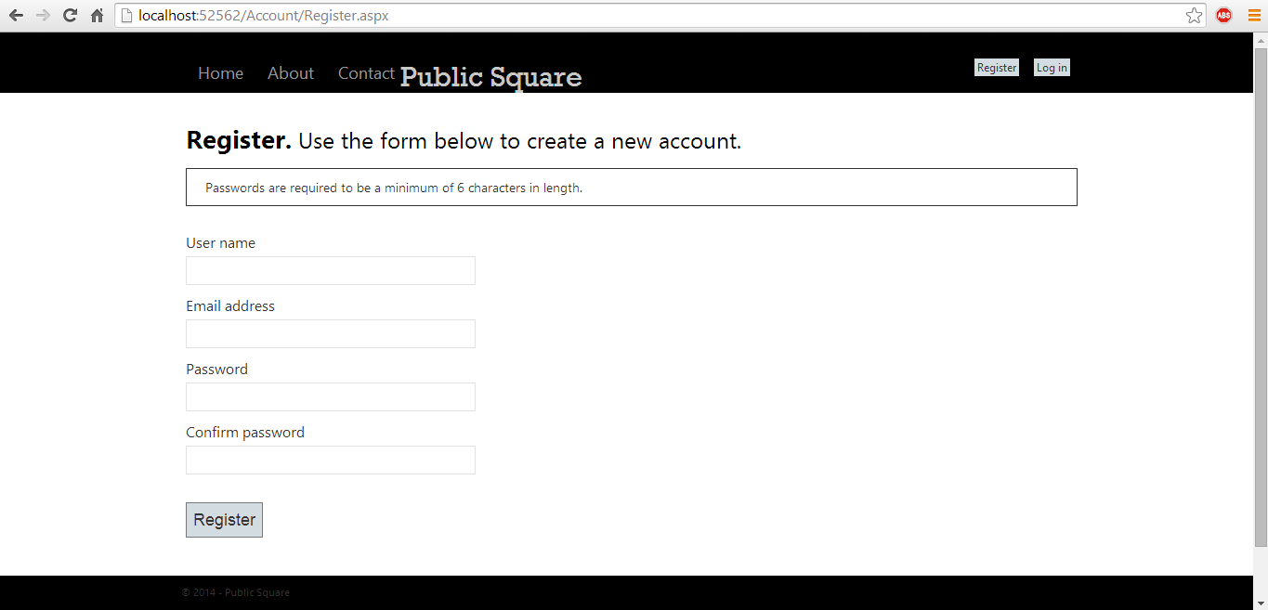

Register and Store it in Database:

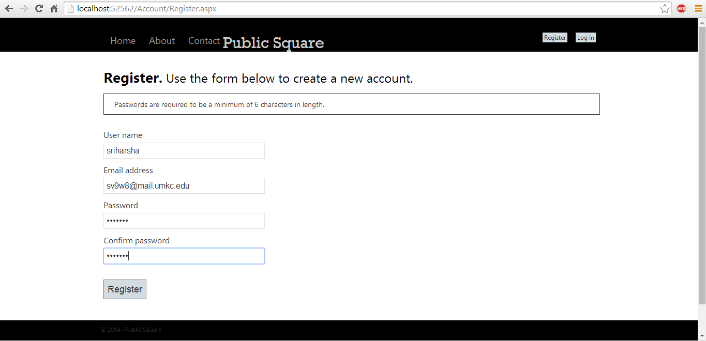

We can see the database file in browser:

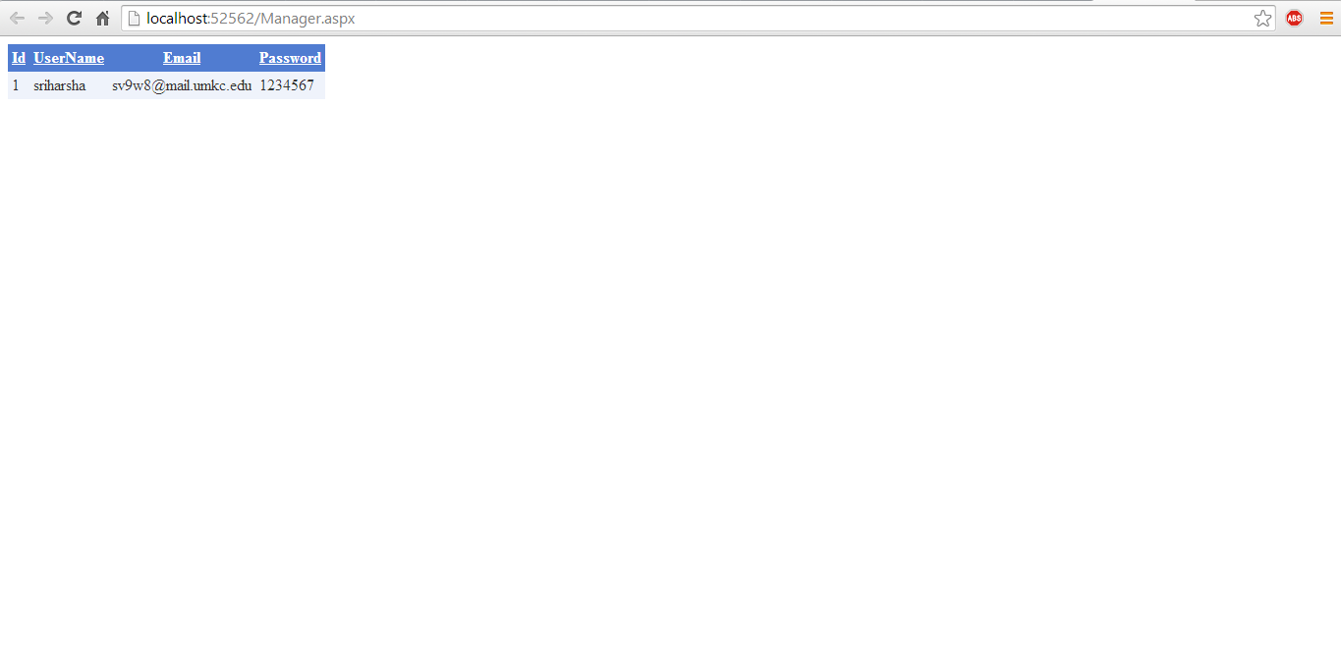

First, Try to Sign up one more time with Same username:

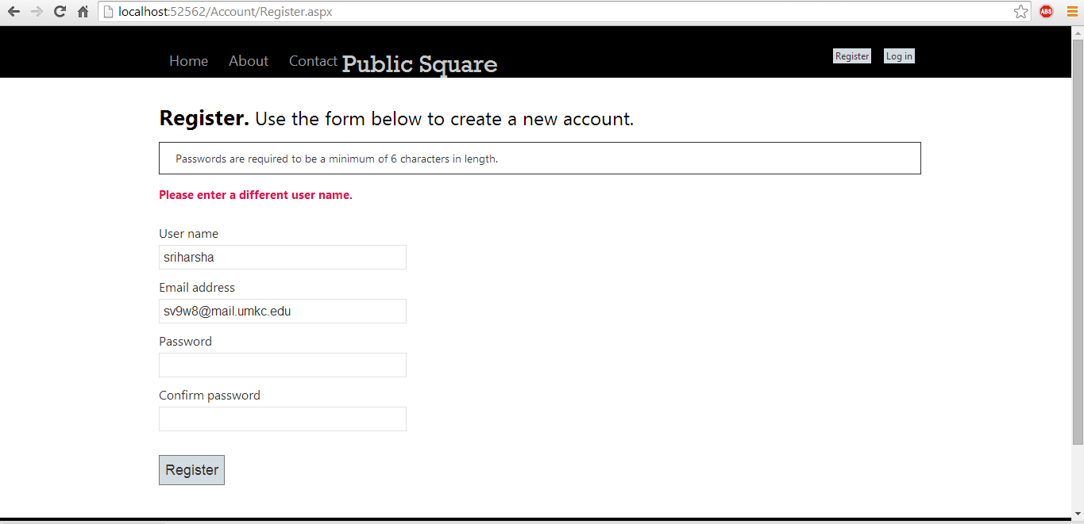

Try to login with different user ID: (i.e. which is not store in database).

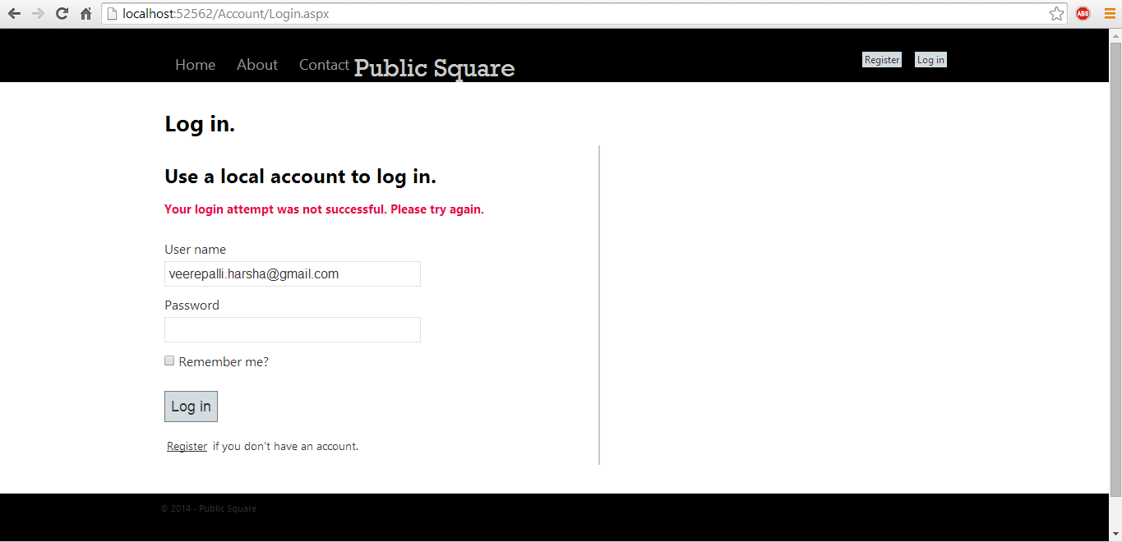

Now, Login with correct user ID:

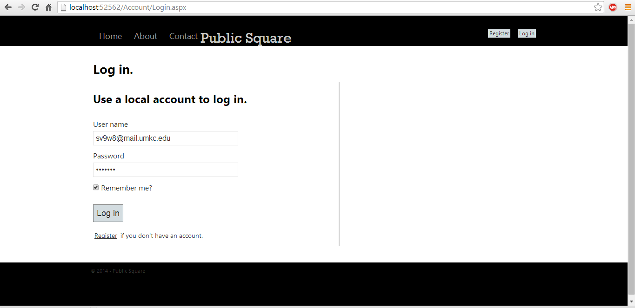

Login in successful and it will ask for OAuth (i.e. external login) Login. Because I used OAuth to store the files in Facebook.

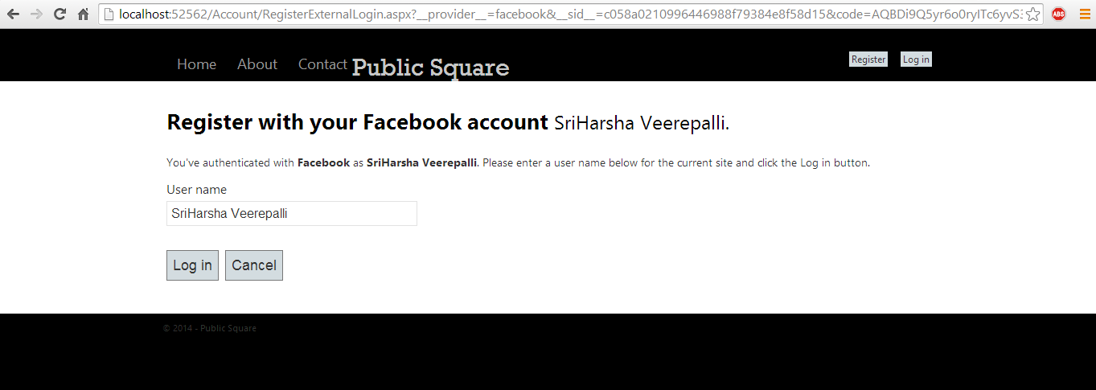

Login with Facebook to share the photos and check-in (Map) place to your friends. Here we can add local password (Optional).

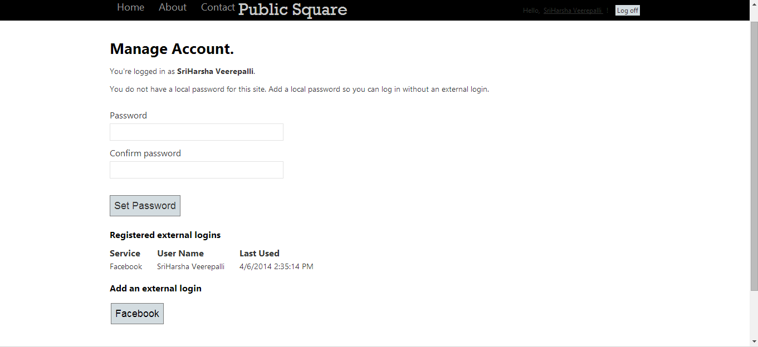

After Finishing go to user profile page.

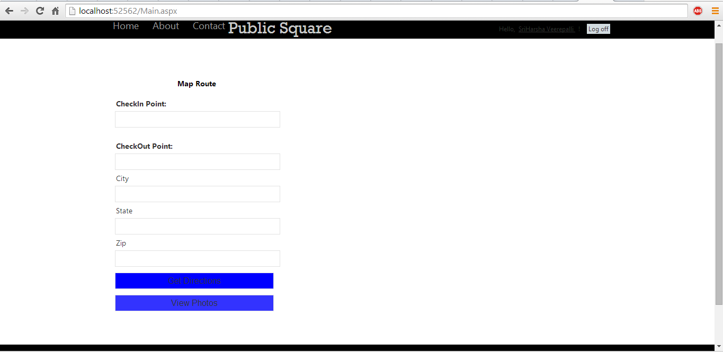

If you give the places and click the get directions button you will get the Route and ‘directions.

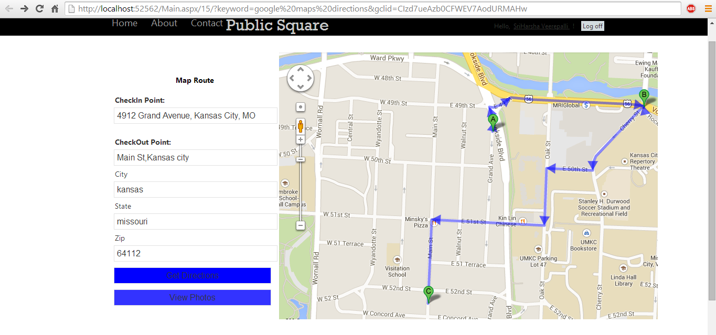

Place the arrow mark on the map.

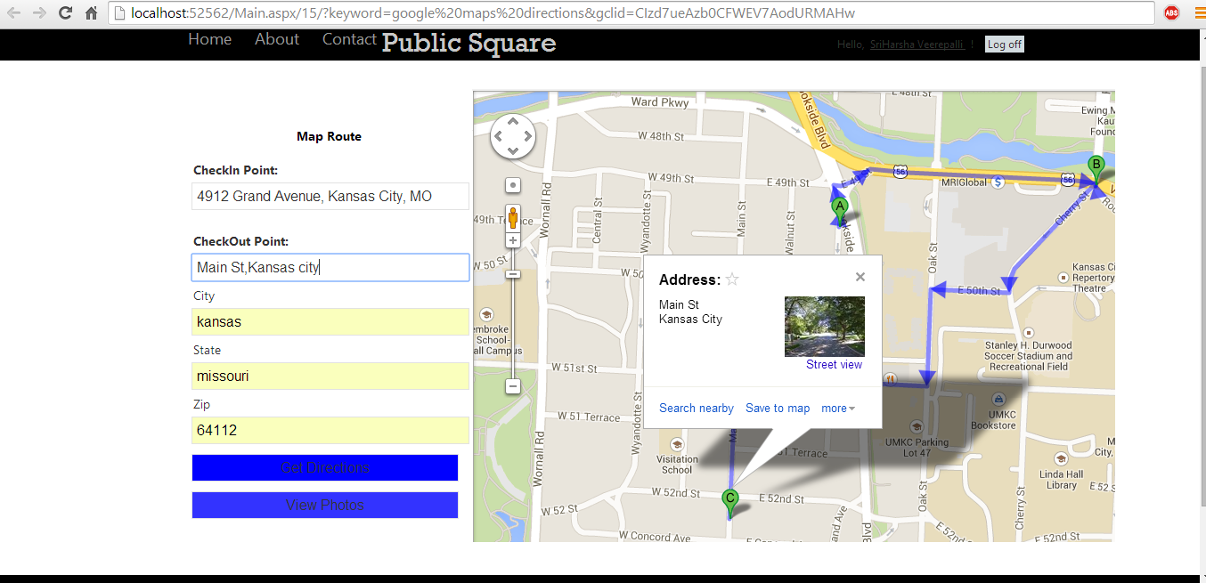

Now click the another button called ViewPhotos. It is used to upload the photos from the mobile or database directly.

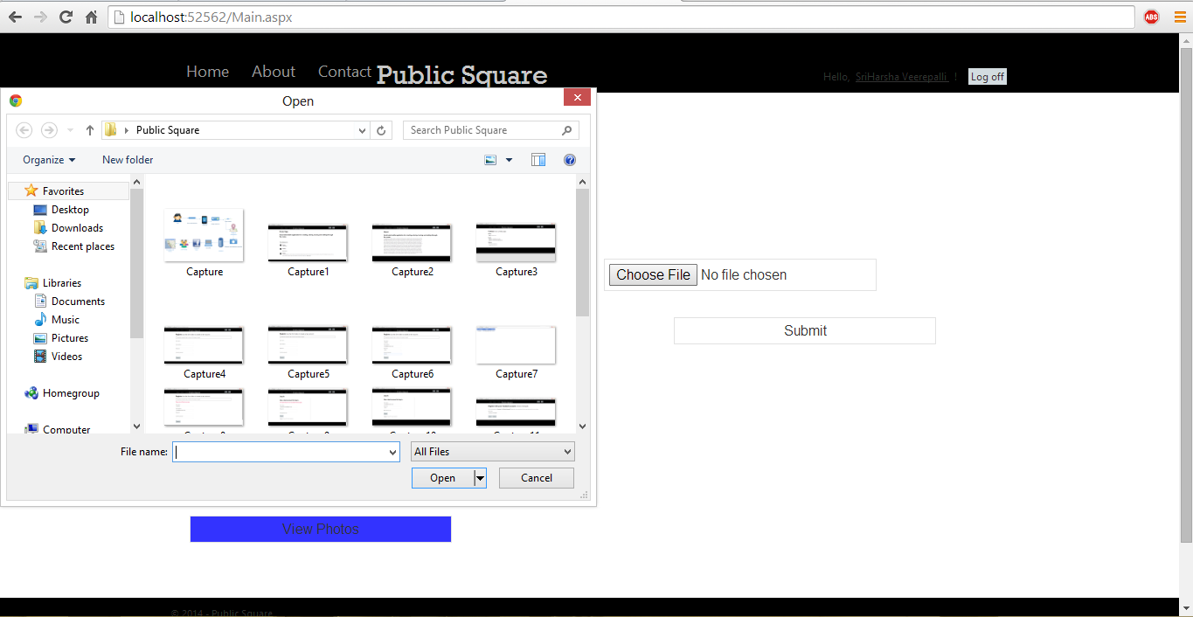

I uploaded photo externally by upload button.

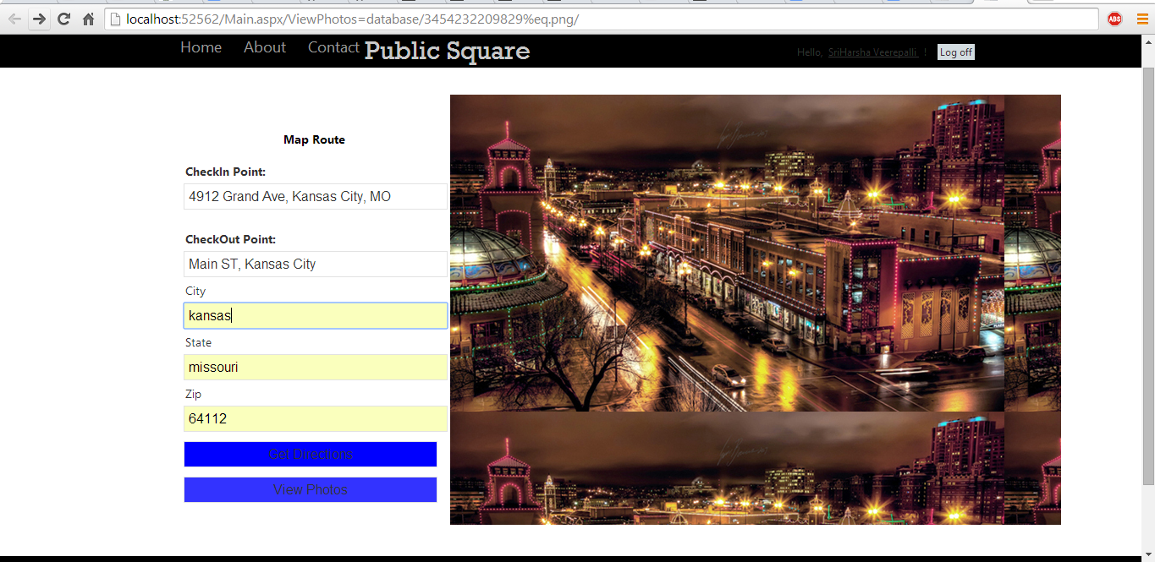

**Software Requirements:**

* Operating system : Windows 8.
* Backend : SQL server, Web service
* Frontend : HTML 5, CSS ,JQuery, Ajax, JavaScript
* Data Base : SQL Server
* Server : IIS Server, Local Host

Limitations:

The limitations in public square is due to lack of time I couldn't able to do the area under taking a picture and share to friends so that a user can upload the images in own profile , but instead I have done placing some images in my database. It can be develop with advanced features if given some more time. I have problem in calling web service so I used JavaScript to get route and directions.

References: I have used the template for the web page by time constraint and modify according to application , so that I can concentrate more on the development of app

<http://hpneo.github.io/gmaps/examples/routes_advanced.html>

Github Link:

<https://github.com/Veerepalli/Mid-term-exam.git>